The Stitch and Rotten Woods

Project Team Members
Matthew Tucker
Zakkary Hucksby
Johnathan Terry

Project Summary
This project is making a mobile platform to play an original Zombie game. The game is home survival that can go on indefinitely. Waves of zombies will spawn and hunt the player down wherever the player goes. Can you survive the Zombie Apocalypse?

Goals and Objectives
The goal of this project is to make a mobile platform to play games on and a game to play. The game should be simple and not require to be plugged in or wife so that in case of a power outage can give someone something to do to pass time.

GitHub Repository
This project's GitHub repository is located at: https://github.com/Pupp3tt/2020CompSci.git
Versions: 2 – one for just keyboard, one for platform
Name of game for keyboard: Game_Keyboard
Name of game for platform: Game_Platform

Bill of Materials
Hardware
Raspberry Pi B v3: $35.00
SmartiPi Touch 2: $27.99
0.093” x 11” x 14” Clear Acrylic sheet x4 - $26.68
MCP3008 - $12.50
Wires multicolor - $19.51
Joysticks x 2 - $4.89
Battery - $ 24.99
Buttons - $7.90
USB to type C x 2 - $7.99
Speaker - $10.00
Wood –
Screws –
Nuts -
Glue –
Paint (Blue, Red, Black, Yellow) - $ 20.00
Brushes - $ 5.00

Software
Python v2.7.9
Pygame v

GPIO and GUI
GPIO is done through breadboard and is connected with wires to buttons, MCP3008, and Joysticks.
Circuit diagram:
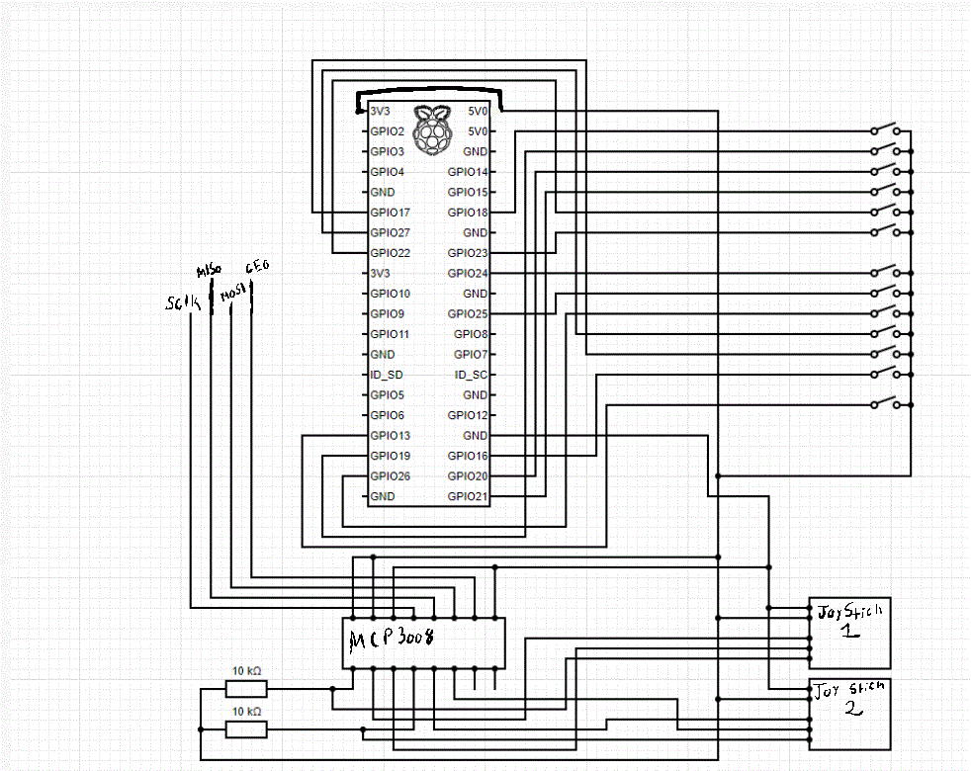
GUI is told to print an image and or abject in code to LCD touchscreen to provide images.
GUI from game:
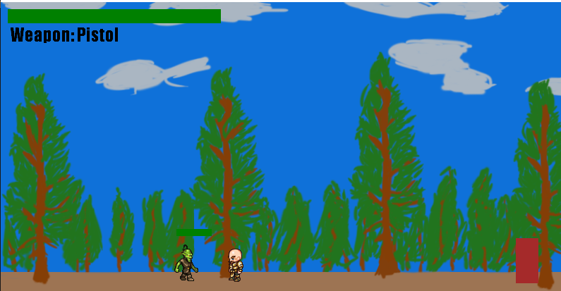

Gantt Chart
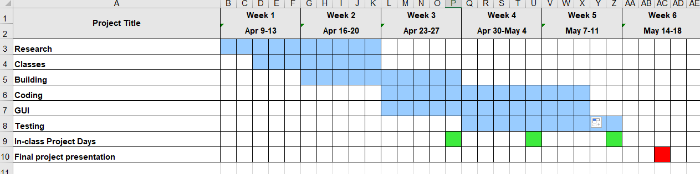

Future Development Plans
Game:
Fix/better scaling
Fix doors
Add weapons image
More than one enemy
Aiming system
More levels
Day nigh cycle
Water/Hunger
Item Drop
Limited ammo
Change zombie and player animation
Add different zombies

Platform:
Allow other games to be played
GUI to select a game

Lessons Learned
Hardware:
MCP3008 and joystick set up and code
Software:
Print/load an image
Animate movement

Relate to Living with Cyber:
Needed to code a lot. The class and the project had to deal with GPIO, inputs, outputs, and GUI.
Problem solving experience:
Needed to find ways around small problems such as:
Bullets changing to arrows when change weapons
When changing to GPIO quick changing weapons to fast
Sized down:
Sized done the project once realized was trying for too much in short time
Future:
Know more about how not to over promise a project in short time
Hardware capabilities and need to do more research
How to do GUI better and simple game style.

